**P.M.ASIK KUSUMSIRI**

**asi**thpdn@yahoo**.com**,

**+94**777999613  
**Maha Aramba, Dandeniya, Galapit**a**mada,**Warakapola.

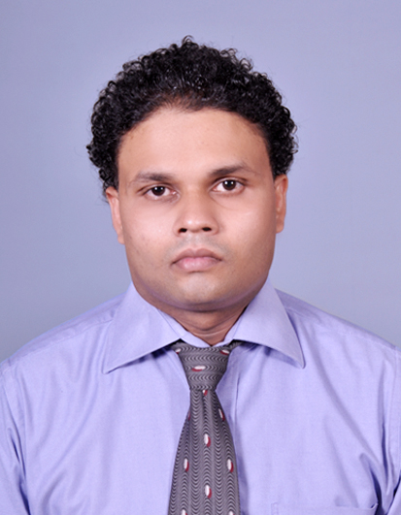

Curriculum Vitae 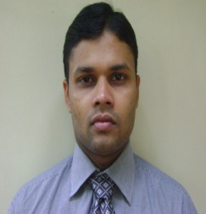

|  |
| --- |
| **OBJECTIVES** |

To contribute for continuous improvement of the excellence of the business with my maximum commitment and dedication are using my experience and the knowledge that I gained so far while widening my horizon and experience.

**EDUCATIONAL QUALIFICATIONS**

* **Following MSc degree programme in Supply Chain and Logistic Management from SLIIT in partnership with Sheffield Hallam University,UK**
* **Following a MBA Degree from University of Wayamba.**
* **Successfully completed Post graduate Diploma in Management from University of Wayamba.**
* **Bachelor of Science (Physical)** -**University of Peradeniya, Sri lanka.**
* **Major Subjects:** **Mathematics\*\***
* Followed **Applied science programme** as my final(Fourth) year from university of Peradeniya.

**G.C.E. (Advanced Level) Examination 2005** -**Dudley Senanayaka College,Tholangamuwa**

1‘B’ grade for Chemistry and

2‘C’ grades for Combined Mathematics & Physics

**G.C.E. (Ordinary Level) Examination 2001**

2 ‘A’ grades and 1 ‘B’ grade, 5‘C’grades

**WORKING EXPERIENCE**

* Have five years working experience in MAS Slimline and MAS Intimates Thurulie as a production Executive (Still working at MAS Holdings-Thurulie).

As a **Production Executive, Slimline (Pvt) Ltd., Pannala** (Present)

1. Manage the effective and efficient use of resources required for the sewing production process to ensure the achievement of agreed production targets within the agreed budget that includes customers such as Victoria’s Secret, Marks & Spencer, Lasenza,H&M etc.
2. Coordinate with team members in order to ascertain viability of production plans.
3. Maintain 6’s in production floor.
4. Ensure timely conduct of the daily Production Meeting with tem leaders and discuss/follow up issues
5. Ensure accurate and timely reporting of output to senior management via reports such as Standard Hours,Efficiency and deliveries.
6. Contribute to the improvement of production processes by trouble shooting and through continuous improvement initiatives in accordance with the lean manufacturing philosophy.

* Manage and supervise 100 employees (incl. Team members, Line Leaders, )

1. Manage the overall sewing production operations from the receipt of cut components through to the assembly and dispatch of completed garments to the customer
2. Planning, organizing, leading and controlling organizational resources in order to ensure achievement of daily key performance parameters with the aid of **SAP AFS 5.0**
3. Ensure timely dispatch of quality controlled goods to customers such as VS, M&S, H&M, Lasenza,Zara.
4. **Actively participates lean implementation activities, projects.**
5. **Member of Factory QCO team.**
6. **Member of factory 6’s team and process improvement team and Kaizen team.**

|  |
| --- |
| **PROFESSIONAL QUALIFICATIONS** |

* ***Following the Green Belt Certificate cource of Lean from Institute of Lean Management.***
* **Overview of lean Management**
* **Integration of other concepts in lean management**
* **Advanced 6S for lean enterprise and concept of “Visual factory”**
* **Concepts of Kaizens**
* **Lean principals and Toyota production system**
* **Hoshin Kanri and floor management development system**
* **9 Types of MUda,Mura,Muri, four types of inflexibility and five sources of invariabilty**
* **Kanban,Standard work,Heijunka,Jidoka, Visual control and Pokayoke**
* **Value added analysis methods and spagetti diagram**
* **Value stream mapping**
* **16 Big losses and Overall Equipment Effectiveness(OEE)**
* **Reactive and proactive problem solving approaches with tools and techniques**
* **ECRS and SMED applications to reduce setup time**
* **Guidelines to create unique lean business model**
* **Have followed certificate course of Yellow Belt Sensei (TPS/Lean Manufacturing)-2012 from MAS intimates.**
* **Have followed certificate course of Blue Belt (Lean Foundation) programme-2012/2013 from MAS intimates.**
* **The member of factory 6’s maintaining team.**
* Have followed an English course in Faculty of Science in university of Peradeniya.
* Have followed GIS & Remote Sensing as a Subject.
* Have followed a MS Office course in AS Computer Center, Galapitamada.

|  |
| --- |
| **COMPUTER LITERACY** |

* Have **SAP AFS 5.0 working knowledge.**
* High competency of Microsoft office packages.
* Competency in Internet & E-mail.
* Have studied Mini Tab Statical package.

|  |
| --- |
| **EXTRA CURRICULAM ACTIVITIES** |

I was ;

* + 1999-2001 Was in the Prefect board of Sri Gunananda Rividina Daham School.
  + Member of the Faculty Art Circle.
  + Member of the University Explores Club.

|  |
| --- |
| **PERSONAL PROFILE** |

* Full Name -: Parana Manannalage Asik Kusumsiri
* NIC No -: 852983612 V
* Date of Birth -: 24.10.1985
* Age -: 29 years
* Nationality -: Sri Lankan
* Gender -: Male

|  |
| --- |
| **REFEREES** |

Mr. Indika Liyanage

Deputy Production Manager

Unichala(Pvt) Ltd

Slimline Devision

Kuliyapitiya Road

Pannala

Telephone: 0773571533

e-mail: indikal@masholdings.com

Mr. Alexander Fernando

QA Deputy Manager

Unichala(Pvt) Ltd

Slimline Devision

Kuliyapitiya Road

Pannala

Telephone: 0777264282

e-mail: alexanderf@masholdings.com

I hereby certify that the above particulars furnished by me are true and accurate to the best of my knowledge

16.11.2015 …………*asik*………….

Signature